PARTICIPANTS: | OC, CC, Systems, Mechanisms, PCAD, SOT Engineers
OVERVIEW: | This procedure describes the actions to be taken by the FOT in the event that ACIS has not been safed in a high radiation environment. This procedure should be run after SOP_OPS_ACIS_UNSAFE_PHASE1. It is assumed that FOT/SOT Engineers are available in the OCC, and that real-time contact is available for at least 2-3 hours, but that back-orbit data from the last pass may not yet be available.
SUMMARY: | Perform actions to recover from any single failure which results in the SIM TT being at > -25,000 steps in a high radiation environment.  There are 3 discrete entry points for this procedure:  A: S/C is not in Safe Mode, and there is no indication of a mechanical stall  B: SIM telemetry indicates that a mechanical stall may have occurred  C: S/C is in Safe Mode, and there is no indication of a mechanical stall  All three cases should be easily distinguishable.  A mechanical stall is indicated when both the TT Stall Counter and Overcurrent Counter are greater than zero. Mechanism thermal conditions that would allow a motor stall to occur without overcurrents are considered to be very unlikely.  This procedure has 10 steps, which will be used in various orders and combinations depending on the cause of the failure. The flowcharts should be used to determine the exact sequence of this procedure. Three of these steps are described by external procedures (referenced below) which the OC will need to have available if there is a chance they will be needed.
CONSTRAINTS: | N/A
INITIAL CONDITIONS: | SIM is in unexpected position  Loads must be halted
EHS DISPLAYS: | F_ MAIN, M_SIMTABLE, M_OTG
GRETA DISPLAYS: | A_1NOC, A_PROCTABLE, EHS_M_OTG
COMPS: | None
SCRIPTS: | O_SCSCTRL M_SW_LETG_RETR_B  I_SAFEINST M_SW_HETG_INSR_B  A_MECH_CONFIG M_LETG_RETR_B_SCS  A_MECH_RECONFIG M_HETG_INSR_B_SCS

PROCEDURES: | SOP_MECH_SEA_RESET_RESPONSE  SEP_MECH_PREPARE_SWAP_SEA  SOP_MECH_SWAP_SEA  SEP_MECH_PREPARE_SIM_TAB2_CROSSING  SOP_MECH_SIM_TAB2_CROSSING  SOP_MECH_SEA_WARM_RESET_RESPONSE  SEP_MECH_SIM_TSC_STALL_RECOVERY  SOP_CCDM_SWAP_SI_RCTU_ATOB  SOP_MECH_SIM_XLATE
COMMAND LOADS | LOAD NAME | CHECKSUM, if SCS
COMMAND LOADS | AA_DEAD60193.CLD  MA_4OLETGRE_241.CLD  MA_4OHETGIN_242.CLD  MA_LMV153_200.CLD  MA_LMV2MC_222.CLD  MA_HINS160_200.CLD | 24F3787  C86FB07  C86F907  501D656  501E304  701D65A
DISABLED COMMANDS: | 4LOLGBDS
COMMAND SYSTEM:
COMMAND SYSTEM: | Clear To Send Mechanism |  | = TIME
COMMAND SYSTEM: | CAR Processing |  | = Enabled
COMMAND SYSTEM: | FSV Processing |  | = Disabled
COMMAND SYSTEM: | Output Format |  | = NRZM
COMMAND SYSTEM: | Minimum Time Delay (sec) |  | = 3
COMMAND SYSTEM: | CAR Time-out (sec) |  | = 40
COMMAND SYSTEM: | FSV Time-out (sec) |  | = 45
COMMAND SYSTEM: | Blocking Factor |  | = 90

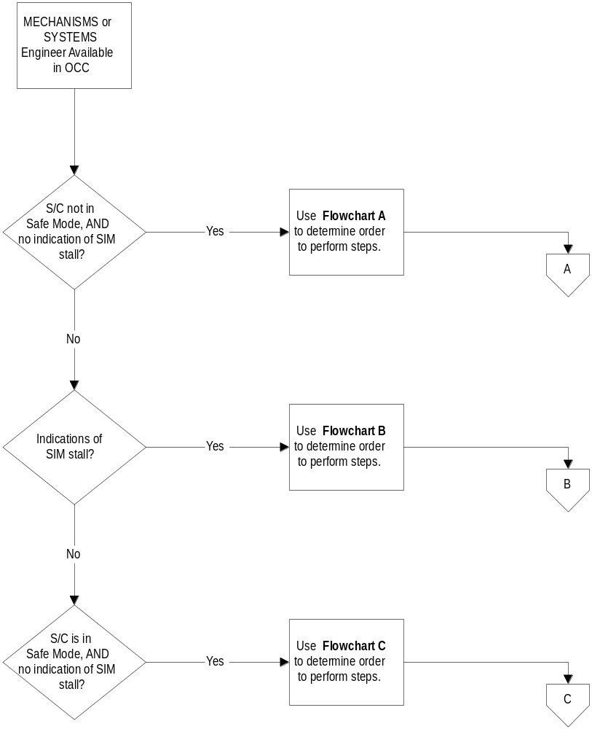FLOWCHARTS:
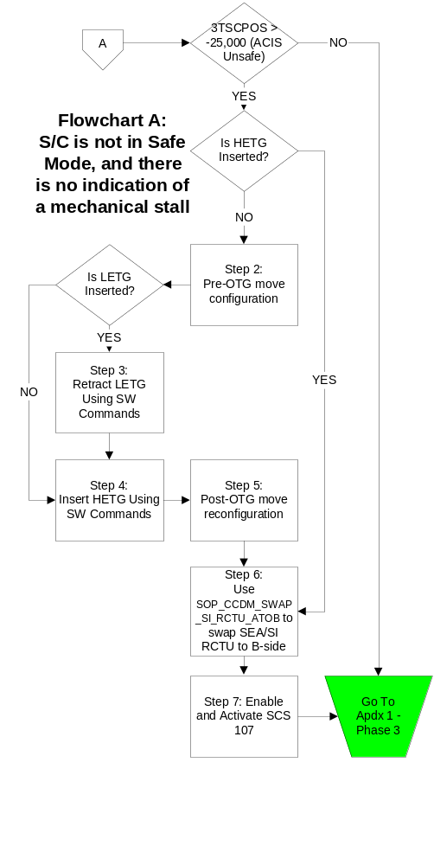
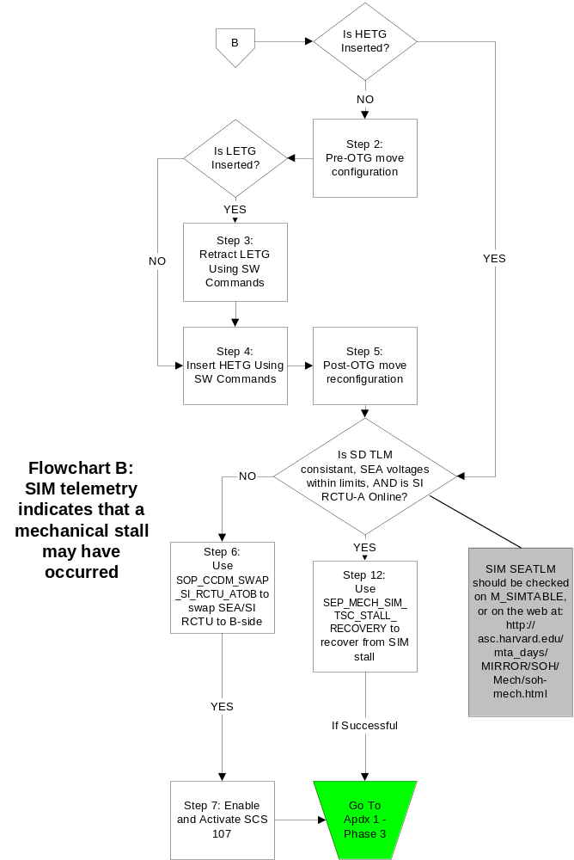

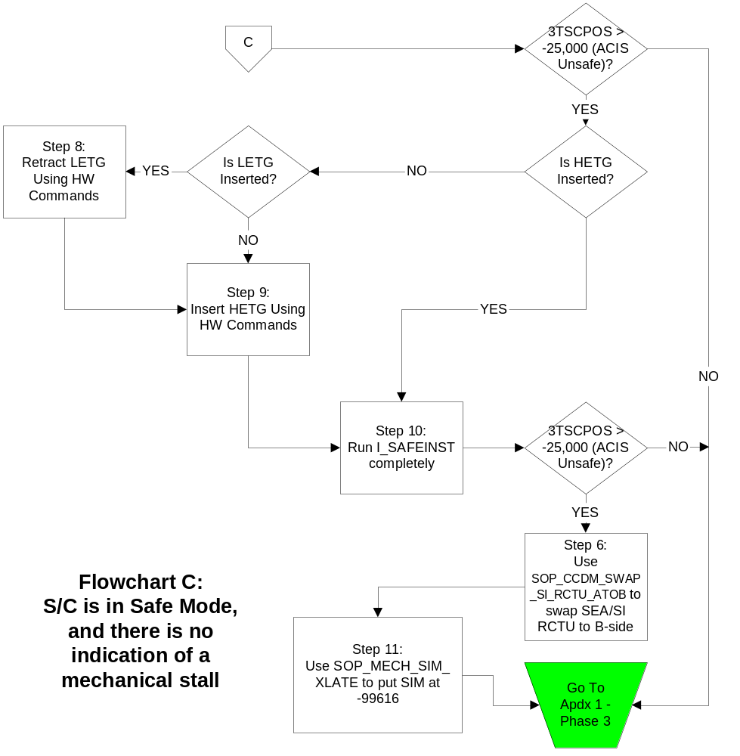

DETERMINE WHICH FLOWCHART DICTATES STEPS

****--------------------------------------------------------- NOTE ---------------------------------------------------------------****
There are 3 discrete entry points for this procedure:
A: S/C is not in Safe Mode, and there is no indication of a mechanical stall
B: SIM telemetry indicates that a mechanical stall may have occurred
C: S/C is in Safe Mode, and there is no indication of a mechanical stall
This procedure has 10 steps, which will be used in various orders and combinations depending on the cause of the failure. The flowcharts should be used to determine the exact sequence of this procedure.

A mechanical stall is indicated if BOTH the stall counter and overcurrent counter are greater than zero.

MSID | DESCRIPTION | DISPLAY | VALUE
3SMOTSTL | SIM TT Stall Counter | M_SIMTABLE.dsp
3SMOTOC | SIM Over Current Counter | M_SIMTABLE.dsp

****----------------------------------------------------------------------------------------------------------------------------------****

If spacecraft is not in Safe Mode, and there is no indication of a mechanical stall refer to Flowchart A for proper sequence of steps to be used in this procedure.

If SIM telemetry indicates a mechanical stall may have occurred refer to Flowchart B for proper sequence of steps to be used in this procedure.

If spacecraft is in Safe Mode, and there is no indication of a mechanical stall refer to Flowchart C for proper sequence of steps to be used in this procedure.

OC Confirm with Mechanisms or Systems Engineers which Flowchart should be used to determine order of steps.

PRE-OTG MOVE CONFIGURATION

****--------------------------------------------------------- NOTE ---------------------------------------------------------------****
This step will configure the spacecraft for OTG motions. It will disable momentum unloading and the momentum monitor, as well as put the spacecraft in NMM.

It is assumed Chandra will be in Normal Point Mode when exiting this procedure. PCAD may choose to execute a CAP in place of Step 2.

Only perform this step after verifying the proper sequence of steps from the appropriate Flowchart.
****----------------------------------------------------------------------------------------------------------------------------------****

Command EPS Subformat

OC Select EPS subformat.

Uplink and Activate Dead Man Load

OC Uplink command load AA_DEAD60193.CLD (60 minute timer).

OC Use script O_SCSCTRL to enable and activate SCS 193.

Command Norm Subformat

OC Select NORM subformat.

Disable PCAD Monitors and go to NMM

OC Begin the following script: A_MECH_CONFIG.

Script will pause at initial WAIT.

OC Resume script.

Script will uplink command AONMMODE.

Verify telemetry:

MSID | Description | Verified
AOPCADMD = NMAN | PCAD Mode

OC Resume script.

Script will uplink command AOMUNLDS.

Verify telemetry:

MSID | Description | Verified
AOAUTUNL = DISA | Auto-unloading Enable/Disable

OC Resume script.

Script will buffer command AOFUNCDS AOPCADSD=32.

OC Uplink buffer.

Verify telemetry:

MSID | Description | Verified
AOPSSCMM = DISA | Momentum Monitor Process

OC Resume to end of script.

Return to flowchart to identify which step should be proceeded to next.

****---------------------------------------------------- WARNING --------------------------------------------------------------****
You must reference the proper Flowchart to determine which step should be performed next.
****----------------------------------------------------------------------------------------------------------------------------------****

LETG RETRACTION by SW command

****--------------------------------------------------------- NOTE ---------------------------------------------------------------****
This step will retract the LETG using software commands.

Only perform this step after verifying the proper sequence of steps from the appropriate Flowchart.
****----------------------------------------------------------------------------------------------------------------------------------****

OC Uplink command load MA_4OLETGRE_241.CLD

OC Begin the following script: M_SW_LETG_RETR_B.

Script will pause at initial WAIT.

Verify Telemetry:

MSID | Description | Verified
4HPOSARO > 79 | HETG A-Side Potentiometer
4HPOSBRO > 79 | HETG B-Side Potentiometer
4LPOSARO < 10 | LETG A-Side Potentiometer
4LPOSBRO < 8 | LETG B-Side Potentiometer

OC Resume script.

Script will uplink command 4MC5AEN and 4MC5BEN.

Verify Telemetry:

MSID | Description | Verified
4M5IRAX = ENAB | MCE A: +5 Volt Conv Inh Relay Monitor
4MP5AV = 5.0 ± 0.5 | MCE A: +5 Volt Monitor
4M5IRBX =ENAB | MCE B: +5 Volt Conv Inh Relay Monitor
4MP5BV = 5.0 ± 0.5 | MCE B: +5 Volt Monitor
4M28IRAX = DISA | MCE A: +28 Volt Conv Inh Relay Mon
4MP28AV = 0.0 ± 0.5 | MCE A: +28 Volt Monitor
4M28IRBX = DISA | MCE B: +28 Volt Conv Inh Relay Mon
4MP28BV = 0.0 ± 0.5 | MCE B: +28 Volt Monitor
4HEXRAX = DISA | MCE A: HETG Execute Relay Status Monitor
4HLORAX = ENAB | MCE A: HETG Hardware Lockout Relay Status Monitor
4HRLSA = NRET | MCE A: HETG Limit Switch 1A Monitor (Retracted)
4HILSA = NINS | MCE A: HETG Limit Switch 2A Monitor (Inserted)
4HEXRBX = DISA | MCE B: HETG Execute Relay Status Monitor
4HLORBX = ENAB | MCE B: HETG Hardware Lockout Relay Status Monitor
4HRLSB = NRET | MCE B: HETG Limit Switch 1B Monitor (Retracted)
4HILSB = NINS | MCE B: HETG Limit Switch 2B Monitor (Inserted)
4LENLAX = DISA | MCE A: LETG Enable Logic Status Monitor
4LEXRAX = DISA | MCE A: LETG Execute Relay Status Monitor
4LLORAX = ENAB | MCE A: LETG Hardware Lockout Relay Status Monitor
4LRLSA = NRET | MCE A: LETG Limit Switch 1A Monitor (Retracted)
4LILSA = INSR | MCE A: LETG Limit Switch 2A Monitor (Inserted)
4LENLBX = DISA | MCE B: LETG Enable Logic Status Monitor
4LEXRBX = DISA | MCE B: LETG Execute Relay Status Monitor
4LLORBX = ENAB | MCE B: LETG Hardware Lockout Relay Status Monitor
4LRLSBD = NRET | MCE B: LETG Limit Switch 1B Monitor (Retracted)
4LILSBD = INSR | MCE B: LETG Limit Switch 2B Monitor (Inserted)

OC Resume script.

Script will uplink command 4MC5BDS

Verify Telemetry:

MSID | Description | Verified
4M5IRBX = DISA | MCE B: +5 Volt Conv Inh Relay Monitor
4MP5BV = 0.0 ± 0.5 | MCE B: +5 Volt Monitor

OC Resume script.

Script will uplink command 400TGPRT

Verify Telemetry:

MSID | Description | Verified
4OOTGDAS = SEC | OTG DATA SOURCE

OC Resume script.

Script will uplink command 4OOTGEN

Verify Telemetry:

MSID | Description | Verified
4OOTGMEF = ENAB | OTG MOTION ENABLE FLAG

OC Resume script.

Script will buffer and send commands COENASX COENAS1=241 and COACTSXCOACTS1=241, COACTS2=0

Verify Telemetry:

MSID | Description | Verified
4OOTGMTN = RETR | ACTION (INSERT/RETRACT SELECTED GRATING)
4OOTGSEL = LETG | SELECTED GRATING
4M5IRAX = ENAB | MCE A: +5 Volt Conv Inh Relay Monitor
4MP5AV = 5.0 ± 0.5 | MCE A: +5 Volt Monitor
4M5IRBX =ENAB | MCE B: +5 Volt Conv Inh Relay Monitor
4MP5BV = 5.0 ± 0.5 | MCE B: +5 Volt Monitor
4M28IRAX = DISA | MCE A: +28 Volt Conv Inh Relay Mon
4MP28AV = 6.5 ± 0.5 | MCE A: +28 Volt Monitor
4M28IRBX = ENAB | MCE B: +28 Volt Conv Inh Relay Mon
4MP28BV = 28.0 ± 0.5 | MCE B: +28 Volt Monitor
4HEXRAX = DISA | MCE A: HETG Execute Relay Status Monitor
4HLORAX = ENAB | MCE A: HETG Hardware Lockout Relay Status Monitor
4HRLSA = NRET | MCE A: HETG Limit Switch 1A Monitor (Retracted)
4HILSA = NINS | MCE A: HETG Limit Switch 2A Monitor (Inserted)
4HEXRBX = DISA | MCE B: HETG Execute Relay Status Monitor
4HLORBX = ENAB | MCE B: HETG Hardware Lockout Relay Status Monitor
4HRLSB = NRET | MCE B: HETG Limit Switch 1B Monitor (Retracted)
4HILSB = NINS | MCE B: HETG Limit Switch 2B Monitor (Inserted)
4LENLAX = DISA | MCE A: LETG Enable Logic Status Monitor
4LEXRAX = DISA | MCE A: LETG Execute Relay Status Monitor
4LLORAX = ENAB | MCE A: LETG Hardware Lockout Relay Status Monitor
4LRLSA = NRET | MCE A: LETG Limit Switch 1A Monitor (Retracted)
4LILSA = INSR -> NINS | MCE A: LETG Limit Switch 2A Monitor (Inserted)
4LENLBX = ENAB | MCE B: LETG Enable Logic Status Monitor
4LEXRBX = ENAB | MCE B: LETG Execute Relay Status Monitor
4LLORBX = DISA -> ENAB | MCE B: LETG Hardware Lockout Relay Status Monitor
4LRLSBD = NRET -> RETR | MCE B: LETG Limit Switch 1B Monitor (Retracted)
4LILSBD = INSR -> NINS | MCE B: LETG Limit Switch 2B Monitor (Inserted)
4LPOSARO ~ 8 -> ~78 | LETG A-Side Potentiometer
4LPOSBRO ~ 6 -> ~78 | LETG B-Side Potentiometer

When retraction has finished:

MSID | Description | Verified
4M5IRAX = ENAB | MCE A: +5 Volt Conv Inh Relay Monitor
4MP5AV = 5.0 ± 0.5 | MCE A: +5 Volt Monitor
4M5IRBX =DISA | MCE B: +5 Volt Conv Inh Relay Monitor
4MP5BV = 0.0 ± 0.5 | MCE B: +5 Volt Monitor
4M28IRAX = DISA | MCE A: +28 Volt Conv Inh Relay Mon
4MP28AV = 0.0 ± 0.5 | MCE A: +28 Volt Monitor
4M28IRBX = DISA | MCE B: +28 Volt Conv Inh Relay Mon
4MP28BV = 0.0 ± 0.5 | MCE B: +28 Volt Monitor
4HEXRAX = DISA | MCE A: HETG Execute Relay Status Monitor
4HLORAX = ENAB | MCE A: HETG Hardware Lockout Relay Status Monitor
4HRLSA = NRET | MCE A: HETG Limit Switch 1A Monitor (Retracted)
4HILSA = NINS | MCE A: HETG Limit Switch 2A Monitor (Inserted)
4LENLAX = DISA | MCE A: LETG Enable Logic Status Monitor
4LEXRAX = DISA | MCE A: LETG Execute Relay Status Monitor
4LLORAX = ENAB | MCE A: LETG Hardware Lockout Relay Status Monitor
4LRLSA = NRET | MCE A: LETG Limit Switch 1A Monitor (Retracted)
4LILSA = NINS | MCE A: LETG Limit Switch 2A Monitor (Inserted)
4LPOSARO ~78 | LETG A-Side Potentiometer
4LPOSBRO ~78 | LETG B-Side Potentiometer

Wait until the move has completed successfully before continuing. The large move should take 153 seconds, and the number of small pulses should be less than 16.

RECORD NUMBER OF SMALL PULSES _________

OC Resume script.

Script will uplink command 4OOTGDS

Verify Telemetry:

MSID | Description | Verified
4OOTGMEF = DISA | OTG MOTION ENABLE FLAG

OC Resume script.

Script will uplink command 4MC5BEN

Verify Telemetry:

MSID | Description | Verified
4M5IRAX = ENAB | MCE A: +5 Volt Conv Inh Relay Monitor
4MP5AV = 5.0 ± 0.5 | MCE A: +5 Volt Monitor
4M5IRBX =ENAB | MCE B: +5 Volt Conv Inh Relay Monitor
4MP5BV = 5.0 ± 0.5 | MCE B: +5 Volt Monitor
4M28IRAX = DISA | MCE A: +28 Volt Conv Inh Relay Mon
4MP28AV = 0.0 ± 0.5 | MCE A: +28 Volt Monitor
4M28IRBX = DISA | MCE B: +28 Volt Conv Inh Relay Mon
4MP28BV = 0.0 ± 0.5 | MCE B: +28 Volt Monitor
4HEXRBX = DISA | MCE B: HETG Execute Relay Status Monitor
4HLORBX = ENAB | MCE B: HETG Hardware Lockout Relay Status Monitor
4HRLSB = NRET | MCE B: HETG Limit Switch 1B Monitor (Retracted)
4HILSB = NINS | MCE B: HETG Limit Switch 2B Monitor (Inserted)
4LENLBX = DISA | MCE B: LETG Enable Logic Status Monitor
4LEXRBX = DISA | MCE B: LETG Execute Relay Status Monitor
4LLORBX = ENAB | MCE B: LETG Hardware Lockout Relay Status Monitor
4LRLSBD = RETR | MCE B: LETG Limit Switch 1B Monitor (Retracted)
4LILSBD = NINS | MCE B: LETG Limit Switch 2B Monitor (Inserted)

OC Resume script.

Script will uplink commands 4MC5BDS and 4MC5ADS

Verify Telemetry:

MSID | Description | Verified
4M5IRAX = DISA | MCE A: +5 Volt Conv Inh Relay Monitor
4MP5AV = 0.0 ± 0.5 | MCE A: +5 Volt Monitor
4M5IRBX =DISA | MCE B: +5 Volt Conv Inh Relay Monitor
4MP5BV = 0.0 ± 0.5 | MCE B: +5 Volt Monitor

OC Resume script.

Script will buffer and send commands CODISASX COCLRS1=241 and COCLRSXCOACTS1=241, COACTS2=0

OC Resume to end of script.

Return to flowchart to identify which step should be proceeded to next.

****------------------------------------------------------ WARNING ------------------------------------------------------------****
You must reference the proper Flowchart to determine which step should be performed next.
****----------------------------------------------------------------------------------------------------------------------------------****

HETG Insertion by SW command

****--------------------------------------------------------- NOTE ---------------------------------------------------------------****
This step will insert the HETG using software commands.

Only perform this step after verifying the proper sequence of steps from the appropriate Flowchart.
****----------------------------------------------------------------------------------------------------------------------------------****

OC Uplink command load MA_4OHETGIN_242.CLD

OC Begin the following script: M_SW_ HETG_INSR_B.

Script will pause at initial WAIT.

Verify Telemetry:

MSID | Description | Verified
4HPOSARO > 79 | HETG A-Side Potentiometer
4HPOSBRO > 79 | HETG B-Side Potentiometer
4LPOSARO > 78 | LETG A-Side Potentiometer
4LPOSBRO > 78 | LETG B-Side Potentiometer

OC Resume script.

Script will uplink command 4MC5AEN and 4MC5BEN.

Verify Telemetry:

MSID | Description | Verified
4M5IRAX = ENAB | MCE A: +5 Volt Conv Inh Relay Monitor
4MP5AV = 5.0 ± 0.5 | MCE A: +5 Volt Monitor
4M5IRBX =ENAB | MCE B: +5 Volt Conv Inh Relay Monitor
4MP5BV = 5.0 ± 0.5 | MCE B: +5 Volt Monitor
4M28IRAX = DISA | MCE A: +28 Volt Conv Inh Relay Mon
4MP28AV = 0.0 ± 0.5 | MCE A: +28 Volt Monitor
4M28IRBX = DISA | MCE B: +28 Volt Conv Inh Relay Mon
4MP28BV = 0.0 ± 0.5 | MCE B: +28 Volt Monitor
4HEXRAX = DISA | MCE A: HETG Execute Relay Status Monitor
4HLORAX = ENAB | MCE A: HETG Hardware Lockout Relay Status Monitor
4HRLSA = NRET | MCE A: HETG Limit Switch 1A Monitor (Retracted)
4HILSA = NINS | MCE A: HETG Limit Switch 2A Monitor (Inserted)
4HEXRBX = DISA | MCE B: HETG Execute Relay Status Monitor
4HLORBX = ENAB | MCE B: HETG Hardware Lockout Relay Status Monitor
4HRLSB = NRET | MCE B: HETG Limit Switch 1B Monitor (Retracted)
4HILSB = NINS | MCE B: HETG Limit Switch 2B Monitor (Inserted)
4LENLAX = DISA | MCE A: LETG Enable Logic Status Monitor
4LEXRAX = DISA | MCE A: LETG Execute Relay Status Monitor
4LLORAX = ENAB | MCE A: LETG Hardware Lockout Relay Status Monitor
4LRLSA = NRET | MCE A: LETG Limit Switch 1A Monitor (Retracted)
4LILSA = NINS | MCE A: LETG Limit Switch 2A Monitor (Inserted)
4LENLBX = DISA | MCE B: LETG Enable Logic Status Monitor
4LEXRBX = DISA | MCE B: LETG Execute Relay Status Monitor
4LLORBX = ENAB | MCE B: LETG Hardware Lockout Relay Status Monitor
4LRLSBD = RETR | MCE B: LETG Limit Switch 1B Monitor (Retracted)
4LILSBD = NINS | MCE B: LETG Limit Switch 2B Monitor (Inserted)

OC Resume script.

Script will uplink command 4MC5BDS

Verify Telemetry:

MSID | Description | Verified
4M5IRBX = DISA | MCE B: +5 Volt Conv Inh Relay Monitor
4MP5BV = 0.0 ± 0.5 | MCE B: +5 Volt Monitor

OC Resume script.

Script will uplink command 400TGPRT

Verify Telemetry:

MSID | Description | Verified
4OOTGDAS = SEC | OTG DATA SOURCE

OC Resume script.

Script will uplink command 4OOTGEN

Verify Telemetry:

MSID | Description | Verified
4OOTGMEF = ENAB | OTG MOTION ENABLE FLAG

OC Resume script.

Script will buffer and send commands COENASX COENAS1=242 and COACTSXCOACTS1=242, COACTS2=0

Verify Telemetry:

MSID | Description | Verified
4OOTGMTN = INSR | ACTION (INSERT/RETRACT SELECTED GRATING)
4OOTGSEL = HETG | SELECTED GRATING
4M5IRAX = ENAB | MCE A: +5 Volt Conv Inh Relay Monitor
4MP5AV = 5.0 ± 0.5 | MCE A: +5 Volt Monitor
4M5IRBX =ENAB | MCE B: +5 Volt Conv Inh Relay Monitor
4MP5BV = 5.0 ± 0.5 | MCE B: +5 Volt Monitor
4M28IRAX = DISA | MCE A: +28 Volt Conv Inh Relay Mon
4MP28AV = 6.0 ± 0.5 | MCE A: +28 Volt Monitor
4M28IRBX = ENAB | MCE B: +28 Volt Conv Inh Relay Mon
4MP28BV = 28.0 ± 0.5 | MCE B: +28 Volt Monitor
4HEXRAX = DISA | MCE A: HETG Execute Relay Status Monitor
4HLORAX = ENAB | MCE A: HETG Hardware Lockout Relay Status Monitor
4HRLSA = NRET | MCE A: HETG Limit Switch 1A Monitor (Retracted)
4HILSA = NINS -> INSR | MCE A: HETG Limit Switch 2A Monitor (Inserted)
4HEXRBX = ENAB | MCE B: HETG Execute Relay Status Monitor
4HLORBX = ENAB | MCE B: HETG Hardware Lockout Relay Status Monitor
4HRLSB = NRET | MCE B: HETG Limit Switch 1B Monitor (Retracted)
4HILSB = NINS -> INSR | MCE B: HETG Limit Switch 2B Monitor (Inserted)
4LENLAX = DISA | MCE A: LETG Enable Logic Status Monitor
4LEXRAX = DISA | MCE A: LETG Execute Relay Status Monitor
4LLORAX = ENAB | MCE A: LETG Hardware Lockout Relay Status Monitor
4LRLSA = NRET | MCE A: LETG Limit Switch 1A Monitor (Retracted)
4LILSA = NINS | MCE A: LETG Limit Switch 2A Monitor (Inserted)
4LENLBX = DISA | MCE B: LETG Enable Logic Status Monitor
4LEXRBX = DISA | MCE B: LETG Execute Relay Status Monitor
4LLORBX = ENAB | MCE B: LETG Hardware Lockout Relay Status Monitor
4LRLSBD = RETR | MCE B: LETG Limit Switch 1B Monitor (Retracted)
4LILSBD = NINS | MCE B: LETG Limit Switch 2B Monitor (Inserted)
4HPOSARO ~ 78 -> ~7 | HETG A-Side Potentiometer
4HPOSBRO ~ 79 -> ~7 | HETG B-Side Potentiometer

When insertion has finished:

MSID | Description | Verified
4M5IRAX = ENAB | MCE A: +5 Volt Conv Inh Relay Monitor
4MP5AV = 5.0 ± 0.5 | MCE A: +5 Volt Monitor
4M5IRBX =DISA | MCE B: +5 Volt Conv Inh Relay Monitor
4MP5BV = 0.0 ± 0.5 | MCE B: +5 Volt Monitor
4M28IRAX = DISA | MCE A: +28 Volt Conv Inh Relay Mon
4MP28AV = 0.0 ± 0.5 | MCE A: +28 Volt Monitor
4M28IRBX = DISA | MCE B: +28 Volt Conv Inh Relay Mon
4MP28BV = 0.0 ± 0.5 | MCE B: +28 Volt Monitor
4HEXRAX = DISA | MCE A: HETG Execute Relay Status Monitor
4HLORAX = ENAB | MCE A: HETG Hardware Lockout Relay Status Monitor
4HRLSA = NRET | MCE A: HETG Limit Switch 1A Monitor (Retracted)
4HILSA = INSR | MCE A: HETG Limit Switch 2A Monitor (Inserted)
4LENLAX = DISA | MCE A: LETG Enable Logic Status Monitor
4LEXRAX = DISA | MCE A: LETG Execute Relay Status Monitor
4LLORAX = ENAB | MCE A: LETG Hardware Lockout Relay Status Monitor
4LRLSA = NRET | MCE A: LETG Limit Switch 1A Monitor (Retracted)
4LILSA = NINS | MCE A: LETG Limit Switch 2A Monitor (Inserted)
4HPOSARO ~7 | HETG A-Side Potentiometer
4HPOSBRO ~7 | HETG B-Side Potentiometer

Wait until the move has completed successfully (~ 155 seconds) before continuing.

OC Resume script.

Script will uplink command 4OOTGDS

Verify Telemetry:

MSID | Description | Verified
4OOTGMEF = DISA | OTG MOTION ENABLE FLAG

OC Resume script.

Script will uplink command 4MC5BEN

Verify Telemetry:

MSID | Description | Verified
4M5IRAX = ENAB | MCE A: +5 Volt Conv Inh Relay Monitor
4MP5AV = 5.0 ± 0.5 | MCE A: +5 Volt Monitor
4M5IRBX =ENAB | MCE B: +5 Volt Conv Inh Relay Monitor
4MP5BV = 5.0 ± 0.5 | MCE B: +5 Volt Monitor
4M28IRAX = DISA | MCE A: +28 Volt Conv Inh Relay Mon
4MP28AV = 0.0 ± 0.5 | MCE A: +28 Volt Monitor
4M28IRBX = DISA | MCE B: +28 Volt Conv Inh Relay Mon
4MP28BV = 0.0 ± 0.5 | MCE B: +28 Volt Monitor
4HEXRBX = DISA | MCE B: HETG Execute Relay Status Monitor
4HLORBX = ENAB | MCE B: HETG Hardware Lockout Relay Status Monitor
4HRLSB = NRET | MCE B: HETG Limit Switch 1B Monitor (Retracted)
4HILSB = INSR | MCE B: HETG Limit Switch 2B Monitor (Inserted)
4LENLBX = DISA | MCE B: LETG Enable Logic Status Monitor
4LEXRBX = DISA | MCE B: LETG Execute Relay Status Monitor
4LLORBX = ENAB | MCE B: LETG Hardware Lockout Relay Status Monitor
4LRLSBD = RETR | MCE B: LETG Limit Switch 1B Monitor (Retracted)
4LILSBD = NINS | MCE B: LETG Limit Switch 2B Monitor (Inserted)

OC Resume script.

Script will uplink commands 4MC5BDS and 4MC5ADS

Verify Telemetry:

MSID | Description | Verified
4M5IRAX = DISA | MCE A: +5 Volt Conv Inh Relay Monitor
4MP5AV = 0.0 ± 0.5 | MCE A: +5 Volt Monitor
4M5IRBX =DISA | MCE B: +5 Volt Conv Inh Relay Monitor
4MP5BV = 0.0 ± 0.5 | MCE B: +5 Volt Monitor

OC Resume script.

Script will buffer and send commands CODISASX COCLRS1=242 and COCLRSXCOACTS1=242, COACTS2=0

OC Resume to end of script.

Return to flowchart to identify which step should be proceeded to next.

****------------------------------------------------------ WARNING ------------------------------------------------------------****
You must reference the proper Flowchart to determine which step should be performed next.
****----------------------------------------------------------------------------------------------------------------------------------****

POST-OTG MOVE RECONFIGURATION

****--------------------------------------------------------- NOTE ---------------------------------------------------------------****
This step will reconfigure the spacecraft after the completion of OTG motions. It will enable momentum unloading and the momentum monitor, as well as put the spacecraft in NPM.

Only perform this step after verifying the proper sequence of steps from the appropriate Flowchart.
****----------------------------------------------------------------------------------------------------------------------------------****

Re-enable PCAD Monitors and return to NPM

OC Begin the following script: A_MECH_RECONFIG.

Script will pause at initial WAIT.

OC Resume script.

Script will uplink command AOFUNCEN AOPCADSE=32

OC Uplink buffer.

Verify telemetry:

MSID | Value
AOPSSCMM | INIT -> ACT

OC Resume script.

Script will uplink command AOMUNLEN.

Verify telemetry:

MSID | Value
AOAUTUNL | ENAB

OC Resume script.

Script will buffer command COACTSX COACTS1=38, COACTS2=0.

OC Uplink buffer.

Verify that all ACA image slots are blank.

OC Resume script.

Script will uplink command AONPMODE.
****--------------------------------------------------------- NOTE ---------------------------------------------------------------****
If Chandra is in Normal Sun Mode, PCAD must write a CAP to disable the Dead Man Load and to reenable momentum unloading and the momentum monitor without returning to Normal Point Mode.
****----------------------------------------------------------------------------------------------------------------------------------****

Verify telemetry:

MSID | Value
AOPCADMD | NPNT
AOACASEQ | AQXN --> GUID --> KALM
AOFSTAR | GUID
AOACQSUC | SUC
AOGDESUC | SUC

OC Resume to end of script.

Disable and clear command load

OC Use script O_SCS_CTRL to CLEAR SCS 193.

Return to flowchart to identify which step should be proceeded to next

****------------------------------------------------------ WARNING ------------------------------------------------------------****
You must reference the proper Flowchart to determine which step should be performed next.
****----------------------------------------------------------------------------------------------------------------------------------****

SWAP SEA/SI-RCTU

****--------------------------------------------------------- NOTE ---------------------------------------------------------------****
Only perform this step after verifying the proper sequence of steps from the appropriate Flowchart.
SOP_CCDM_SWAP_SI_RCTU_ATOB references procedure SOP_MECH_SWAP_SEA to swap to SEA-B.
****----------------------------------------------------------------------------------------------------------------------------------****

Perform all the steps in SOP_CCDM_SWAP_SI_RCTU_ATOB to switch the SEA and SI-RCTU to the B-side units.

OC Execute SOP_CCDM_SWAP_SI_RCTU_ATOB

Return to flowchart to identify which step should be proceeded to next.

****------------------------------------------------------ WARNING ------------------------------------------------------------****
You must reference the proper Flowchart to determine which step should be performed next.
****----------------------------------------------------------------------------------------------------------------------------------****

RUN SCS 107

****--------------------------------------------------------- NOTE ---------------------------------------------------------------****
Only perform this step after verifying the proper sequence of steps from the appropriate Flowchart.
****----------------------------------------------------------------------------------------------------------------------------------****

Run SCS 107

OC - Using script O_PROT_SCSCTRL, ENABLE AND ACTIVATE SCS 107.

Return to flowchart to identify which step should be proceeded to next.

****------------------------------------------------------ WARNING ------------------------------------------------------------****
You must reference the proper Flowchart to determine which step should be performed next.
****----------------------------------------------------------------------------------------------------------------------------------****

RETRACT LETG USING HW COMMANDS

****--------------------------------------------------------- NOTE ---------------------------------------------------------------****
This step will retract the LETG using hardware commands.

Only perform this step after verifying the proper sequence of steps from the appropriate Flowchart.
****----------------------------------------------------------------------------------------------------------------------------------****

Request GOT to enable disabled command 4LOLGBDS.

Uplink the following command loads:

Load Name | Checksum
MA_LMV153_200.CLD | 501D656
MA_LMV2MC_222.CLD | 501E304

OC Uplink the above 2 loads and verify good memload.

LETG Retraction by Hardware Commands

OC Begin the following script: M_LETG_RETR_B_SCS.

Script will pause at initial WAIT.

Verify Telemetry:

MSID | Description | Verified
4HPOSARO > 79 | HETG A-Side Potentiometer
4HPOSBRO > 79 | HETG B-Side Potentiometer
4LPOSARO < 10 | LETG A-Side Potentiometer
4LPOSBRO < 8 | LETG B-Side Potentiometer

OC Resume script.

Script will uplink commands 4MC5AEN, 4MC5BEN, 4SLLGBEN, 4SLLGAEN, 4RTLGBEN, 4MC28BEN, and 4LOLGBDS.

Verify Telemetry:

MSID | Description | Verified
4M5IRAX = ENAB | MCE A: +5 Volt Conv Inh Relay Monitor
4MP5AV = 5.0 ± 0.5 | MCE A: +5 Volt Monitor
4M5IRBX =ENAB | MCE B: +5 Volt Conv Inh Relay Monitor
4MP5BV = 5.0 ± 0.5 | MCE B: +5 Volt Monitor
4M28IRAX = DISA | MCE A: +28 Volt Conv Inh Relay Mon
4MP28AV = 0.0 ± 0.5 | MCE A: +28 Volt Monitor
4M28IRBX = DISA | MCE B: +28 Volt Conv Inh Relay Mon
4MP28BV = 28.0 ± 0.5 | MCE B: +28 Volt Monitor
4HENLAX = DISA | MCE A: HETG Enable Logic Status Monitor
4HEXRAX = DISA | MCE A: HETG Execute Relay Status Monitor
4HLORAX = ENAB | MCE A: HETG Hardware Lockout Relay Status Monitor
4HRLSA = NRET | MCE A: HETG Limit Switch 1A Monitor (Retracted)
4HILSA = NINS | MCE A: HETG Limit Switch 2A Monitor (Inserted)
4HENLBX = DISA | MCE B: HETG Enable Logic Status Monitor
4HEXRBX = DISA | MCE B: HETG Execute Relay Status Monitor
4HLORBX = ENAB | MCE B: HETG Hardware Lockout Relay Status Monitor
4HRLSB = NRET | MCE B: HETG Limit Switch 1B Monitor (Retracted)
4HILSB = NINS | MCE B: HETG Limit Switch 2B Monitor (Inserted)
4LENLAX = DISA | MCE A: LETG Enable Logic Status Monitor
4LEXRAX = DISA | MCE A: LETG Execute Relay Status Monitor
4LLORAX = ENAB | MCE A: LETG Hardware Lockout Relay Status Monitor
4LRLSA = NRET | MCE A: LETG Limit Switch 1A Monitor (Retracted)
4LILSA = INSR | MCE A: LETG Limit Switch 2A Monitor (Inserted)
4LENLBX = ENAB | MCE B: LETG Enable Logic Status Monitor
4LEXRBX = DISA | MCE B: LETG Execute Relay Status Monitor
4LLORBX = DISA | MCE B: LETG Hardware Lockout Relay Status Monitor
4LRLSBD = NRET | MCE B: LETG Limit Switch 1B Monitor (Retracted)
4LILSBD = INSR | MCE B: LETG Limit Switch 2B Monitor (Inserted)
4LRSMA = SELE | MCE A: OTG Select Relay Status Monitor – LETG
4LRSMB = SELE | MCE B: OTG Select Relay Status Monitor – LETG
4LDIRB = RETR | MCE B: LETG Direction Relay Status Monitor

OC Resume script, and send buffer.

Script will buffer and send commands COENASX COENAS1=200 and COACTSXCOACTS1=200, COACTS2=0

Verify Telemetry:

MSID | Description | Verified
4M5IRAX = ENAB | MCE A: +5 Volt Conv Inh Relay Monitor
4MP5AV = 5.0 ± 0.5 | MCE A: +5 Volt Monitor
4M5IRBX =ENAB | MCE B: +5 Volt Conv Inh Relay Monitor
4MP5BV = 5.0 ± 0.5 | MCE B: +5 Volt Monitor
4M28IRAX = DISA | MCE A: +28 Volt Conv Inh Relay Mon
4MP28AV = 7.0 ± 0.5 | MCE A: +28 Volt Monitor
4M28IRBX = ENAB | MCE B: +28 Volt Conv Inh Relay Mon
4MP28BV = 28.0 ± 0.5 | MCE B: +28 Volt Monitor
4HENLAX = DISA | MCE A: HETG Enable Logic Status Monitor
4HEXRAX = DISA | MCE A: HETG Execute Relay Status Monitor
4HLORAX = ENAB | MCE A: HETG Hardware Lockout Relay Status Monitor
4HRLSA = NRET | MCE A: HETG Limit Switch 1A Monitor (Retracted)
4HILSA = NINS | MCE A: HETG Limit Switch 2A Monitor (Inserted)
4HENLBX = DISA | MCE B: HETG Enable Logic Status Monitor
4HEXRBX = DISA | MCE B: HETG Execute Relay Status Monitor
4HLORBX = ENAB | MCE B: HETG Hardware Lockout Relay Status Monitor
4HRLSB = NRET | MCE B: HETG Limit Switch 1B Monitor (Retracted)
4HILSB = NINS | MCE B: HETG Limit Switch 2B Monitor (Inserted)
4LENLAX = DISA | MCE A: LETG Enable Logic Status Monitor
4LEXRAX = DISA | MCE A: LETG Execute Relay Status Monitor
4LLORAX = ENAB | MCE A: LETG Hardware Lockout Relay Status Monitor
4LRLSA = NRET | MCE A: LETG Limit Switch 1A Monitor (Retracted)
4LILSA = INSR -> NINS | MCE A: LETG Limit Switch 2A Monitor (Inserted)
4LENLBX = ENAB | MCE B: LETG Enable Logic Status Monitor
4LEXRBX = ENAB/DISA | MCE B: LETG Execute Relay Status Monitor
4LLORBX = DISA | MCE B: LETG Hardware Lockout Relay Status Monitor
4LRLSBD = NRET -> RETR | MCE B: LETG Limit Switch 1B Monitor (Retracted)
4LILSBD = INSR -> NINS | MCE B: LETG Limit Switch 2B Monitor (Inserted)
4LPOSARO ~ 8 -> ~78 | LETG A-Side Potentiometer
4LPOSBRO ~ 6 -> ~78 | LETG B-Side Potentiometer

OC Resume script by entering "2MC" at the prompt, and sending the buffer. Repeat this step until the LETG is retracted. Then enter "NONE" at the prompt.

Script will buffer and send commands COENASX COENAS1=222 and COACTSXCOACTS1=222, COACTS2=0

Verify Telemetry:

MSID | Description | Verified
4M5IRAX = ENAB | MCE A: +5 Volt Conv Inh Relay Monitor
4MP5AV = 5.0 ± 0.5 | MCE A: +5 Volt Monitor
4M5IRBX =ENAB | MCE B: +5 Volt Conv Inh Relay Monitor
4MP5BV = 5.0 ± 0.5 | MCE B: +5 Volt Monitor
4M28IRAX = DISA | MCE A: +28 Volt Conv Inh Relay Mon
4MP28AV = 0.0 ± 0.5 | MCE A: +28 Volt Monitor
4M28IRBX = ENAB | MCE B: +28 Volt Conv Inh Relay Mon
4MP28BV = 28.0 ± 0.5 | MCE B: +28 Volt Monitor
4HENLAX = DISA | MCE A: HETG Enable Logic Status Monitor
4HEXRAX = DISA | MCE A: HETG Execute Relay Status Monitor
4HLORAX = ENAB | MCE A: HETG Hardware Lockout Relay Status Monitor
4HRLSA = NRET | MCE A: HETG Limit Switch 1A Monitor (Retracted)
4HILSA = NINS | MCE A: HETG Limit Switch 2A Monitor (Inserted)
4HENLBX = DISA | MCE B: HETG Enable Logic Status Monitor
4HEXRBX = DISA | MCE B: HETG Execute Relay Status Monitor
4HLORBX = ENAB | MCE B: HETG Hardware Lockout Relay Status Monitor
4HRLSB = NRET | MCE B: HETG Limit Switch 1B Monitor (Retracted)
4HILSB = NINS | MCE B: HETG Limit Switch 2B Monitor (Inserted)
4LENLAX = DISA | MCE A: LETG Enable Logic Status Monitor
4LEXRAX = DISA | MCE A: LETG Execute Relay Status Monitor
4LLORAX = ENAB | MCE A: LETG Hardware Lockout Relay Status Monitor
4LRLSA = NRET | MCE A: LETG Limit Switch 1A Monitor (Retracted)
4LILSA = NINS | MCE A: LETG Limit Switch 2A Monitor (Inserted)
4LENLBX = ENAB | MCE B: LETG Enable Logic Status Monitor
4LEXRBX = ENAB | MCE B: LETG Execute Relay Status Monitor
4LLORBX = DISA | MCE B: LETG Hardware Lockout Relay Status Monitor
4LRLSBD = RETR | MCE B: LETG Limit Switch 1B Monitor (Retracted)
4LILSBD = NINS | MCE B: LETG Limit Switch 2B Monitor (Inserted)
4LPOSARO ~78 | LETG A-Side Potentiometer
4LPOSBRO ~78 | LETG B-Side Potentiometer

Each activation after the first should cause an invalid SCS transition OBC error.

RECORD NUMBER OF SMALL PULSES _________

OC Resume script.

Script will uplink command 4LOLGBEN

Verify Telemetry:

MSID | Description | Verified
4LLORBX = ENAB | MCE B: LETG Hardware Lockout Relay Status Monitor

OC Resume script.

Script will uplink commands 4MC28BDS, 4MC5BDS, and 4MC5ADS.

Verify Telemetry:

MSID | Description | Verified
4M5IRAX = DISA | MCE A: +5 Volt Conv Inh Relay Monitor
4MP5AV = 0.0 ± 0.5 | MCE A: +5 Volt Monitor
4M5IRBX =DISA | MCE B: +5 Volt Conv Inh Relay Monitor
4MP5BV = 0.0 ± 0.5 | MCE B: +5 Volt Monitor
4M28IRAX = DISA | MCE A: +28 Volt Conv Inh Relay Mon
4MP28AV = 0.0 ± 0.5 | MCE A: +28 Volt Monitor
4M28IRBX = DISA | MCE B: +28 Volt Conv Inh Relay Mon
4MP28BV = 0.0 ± 0.5 | MCE B: +28 Volt Monitor

Script will buffer commands to disable and clear SCS 200, 201-203, 211-213, and 221-223.

OC Send buffer and resume to end of script.

This should cause 16 additional invalid SCS transition errors.

Return to flowchart to identify which step should be proceeded to next.

****------------------------------------------------------ WARNING ------------------------------------------------------------****
You must reference the proper Flowchart to determine which step should be performed next.
****----------------------------------------------------------------------------------------------------------------------------------****

INSERT HETG BY HW COMMANDS

****--------------------------------------------------------- NOTE ---------------------------------------------------------------****
This step will insert the LETG using hardware commands.

Only perform this step after verifying the proper sequence of steps from the appropriate Flowchart.
****----------------------------------------------------------------------------------------------------------------------------------****

Uplink the following command loads:

Load Name | Checksum
MA_HINS160_200.CLD | 701D65A

OC Uplink the above load and verify good memload.

HETG Insertion by Hardware Commands

OC Begin the following script: M_HETG_INSR_B_SCS.

Script will pause at initial WAIT.

Verify Telemetry:

MSID | Description | Verified
4HPOSARO > 78 | HETG A-Side Potentiometer
4HPOSBRO > 78 | HETG B-Side Potentiometer
4LPOSARO > 78 | LETG A-Side Potentiometer
4LPOSBRO > 78 | LETG B-Side Potentiometer

OC Resume script.

Script will uplink commands 4MC5AEN, 4MC5BEN, 4SLHGBEN, 4SLHGAEN, 4INHGBEN, and 4MC28BEN.

Verify Telemetry:

MSID | Description | Verified
4M5IRAX = ENAB | MCE A: +5 Volt Conv Inh Relay Monitor
4MP5AV = 5.0 ± 0.5 | MCE A: +5 Volt Monitor
4M5IRBX =ENAB | MCE B: +5 Volt Conv Inh Relay Monitor
4MP5BV = 5.0 ± 0.5 | MCE B: +5 Volt Monitor
4M28IRAX = DISA | MCE A: +28 Volt Conv Inh Relay Mon
4MP28AV = 0.0 ± 0.5 | MCE A: +28 Volt Monitor
4M28IRBX = ENAB | MCE B: +28 Volt Conv Inh Relay Mon
4MP28BV = 28.0 ± 0.5 | MCE B: +28 Volt Monitor
4HEXRAX = DISA | MCE A: HETG Execute Relay Status Monitor
4HLORAX = ENAB | MCE A: HETG Hardware Lockout Relay Status Monitor
4HRLSA = NRET | MCE A: HETG Limit Switch 1A Monitor (Retracted)
4HILSA = NINS | MCE A: HETG Limit Switch 2A Monitor (Inserted)
4HENLBX = ENAB | MCE B: HETG Enable Logic Status Monitor
4HEXRBX = DISA | MCE B: HETG Execute Relay Status Monitor
4HLORBX = ENAB | MCE B: HETG Hardware Lockout Relay Status Monitor
4HRLSB = NRET | MCE B: HETG Limit Switch 1B Monitor (Retracted)
4HILSB = NINS | MCE B: HETG Limit Switch 2B Monitor (Inserted)
4LENLAX = DISA | MCE A: LETG Enable Logic Status Monitor
4LEXRAX = DISA | MCE A: LETG Execute Relay Status Monitor
4LLORAX = ENAB | MCE A: LETG Hardware Lockout Relay Status Monitor
4LRLSA = NRET | MCE A: LETG Limit Switch 1A Monitor (Retracted)
4LILSA = NINS | MCE A: LETG Limit Switch 2A Monitor (Inserted)
4LENLBX = DISA | MCE B: LETG Enable Logic Status Monitor
4LEXRBX = DISA | MCE B: LETG Execute Relay Status Monitor
4LLORBX = ENAB | MCE B: LETG Hardware Lockout Relay Status Monitor
4LRLSBD = RETR | MCE B: LETG Limit Switch 1B Monitor (Retracted)
4LILSBD = NINS | MCE B: LETG Limit Switch 2B Monitor (Inserted)
4HRSMA = SELE | MCE A: OTG Select Relay Status Monitor – HETG
4HRSMB = SELE | MCE B: OTG Select Relay Status Monitor – HETG
4HDIRB = INSR | MCE B: HETG Direction Relay Status Monitor

OC Resume script, and send buffer.

Script will buffer and send commands COENASX COENAS1=200 and COACTSX COACTS1=200, COACTS2=0

Verify Telemetry:

MSID | Description | Verified
4M5IRAX = ENAB | MCE A: +5 Volt Conv Inh Relay Monitor
4MP5AV = 5.0 ± 0.5 | MCE A: +5 Volt Monitor
4M5IRBX =ENAB | MCE B: +5 Volt Conv Inh Relay Monitor
4MP5BV = 5.0 ± 0.5 | MCE B: +5 Volt Monitor
4M28IRAX = DISA | MCE A: +28 Volt Conv Inh Relay Mon
4MP28AV = 6.0 ± 0.5 | MCE A: +28 Volt Monitor
4M28IRBX = ENAB | MCE B: +28 Volt Conv Inh Relay Mon
4MP28BV = 28.0 ± 0.5 | MCE B: +28 Volt Monitor
4HENLAX = DISA | MCE A: HETG Enable Logic Status Monitor
4HEXRAX = DISA | MCE A: HETG Execute Relay Status Monitor
4HLORAX = ENAB | MCE A: HETG Hardware Lockout Relay Status Monitor
4HRLSA = NRET | MCE A: HETG Limit Switch 1A Monitor (Retracted)
4HILSA = NINS -> INSR | MCE A: HETG Limit Switch 2A Monitor (Inserted)
4HENLBX = ENAB -> DISA | MCE B: HETG Enable Logic Status Monitor
4HEXRBX = ENAB -> DISA | MCE B: HETG Execute Relay Status Monitor
4HLORBX = ENAB | MCE B: HETG Hardware Lockout Relay Status Monitor
4HRLSB = NRET | MCE B: HETG Limit Switch 1B Monitor (Retracted)
4HILSB = NINS -> INSR | MCE B: HETG Limit Switch 2B Monitor (Inserted)
4LENLAX = DISA | MCE A: LETG Enable Logic Status Monitor
4LEXRAX = DISA | MCE A: LETG Execute Relay Status Monitor
4LLORAX = ENAB | MCE A: LETG Hardware Lockout Relay Status Monitor
4LRLSA = NRET | MCE A: LETG Limit Switch 1A Monitor (Retracted)
4LILSA = NINS | MCE A: LETG Limit Switch 2A Monitor (Inserted)
4LENLBX = DISA | MCE B: LETG Enable Logic Status Monitor
4LEXRBX = DISA | MCE B: LETG Execute Relay Status Monitor
4LLORBX = ENAB | MCE B: LETG Hardware Lockout Relay Status Monitor
4LRLSBD = RETR | MCE B: LETG Limit Switch 1B Monitor (Retracted)
4LILSBD = NINS | MCE B: LETG Limit Switch 2B Monitor (Inserted)
4HPOSARO ~79 -> ~7 | HETG A-Side Potentiometer
4HPOSBRO ~79 -> ~7 | HETG B-Side Potentiometer

OC Resume script by entering "NONE" at the prompt.

OC Resume script.

Script will uplink commands 4MC28BDS, 4MC5BDS, and 4MC5ADS.

Verify Telemetry:

MSID | Description | Verified
4M5IRAX = DISA | MCE A: +5 Volt Conv Inh Relay Monitor
4MP5AV = 0.0 ± 0.5 | MCE A: +5 Volt Monitor
4M5IRBX =DISA | MCE B: +5 Volt Conv Inh Relay Monitor
4MP5BV = 0.0 ± 0.5 | MCE B: +5 Volt Monitor
4M28IRAX = DISA | MCE A: +28 Volt Conv Inh Relay Mon
4MP28AV = 0.0 ± 0.5 | MCE A: +28 Volt Monitor
4M28IRBX = DISA | MCE B: +28 Volt Conv Inh Relay Mon
4MP28BV = 0.0 ± 0.5 | MCE B: +28 Volt Monitor

OC Resume to end of script.

OC Using script O_SCSCTRL, disable and clear SCS 200.

Return to flowchart to identify which step should be proceeded to next.

****------------------------------------------------------ WARNING ------------------------------------------------------------****
You must reference the proper Flowchart to determine which step should be performed next.
****----------------------------------------------------------------------------------------------------------------------------------****

RUN SCRIPT I_SAFEINST

****--------------------------------------------------------- NOTE ---------------------------------------------------------------****
Only perform this step after verifying the proper sequence of steps from the appropriate Flowchart.
****----------------------------------------------------------------------------------------------------------------------------------****

Run Script I_SAFEINST

OC - Start Script I_SAFEINST

****--------------------------------------------------------- NOTE ---------------------------------------------------------------****
The I_SAFEINST script is designed to perform the same function as SCS 107 if, for whatever reason, SCS 107 cannot do the job. If this step is being performed, it is likely that there is some OBC/SEA/RCTU malfunction preventing the successful completion of SI safing actions. While this script will only serve as a work-around for OBC-related problems, it is recommended that this action be taken before the SI-RCTU/SEA swap (Step 6) when following Flowchart C, as this script does not require any (possibly unnecessary) HW swapping. Of course, if Engineering believes that the problem clearly lies in the SI-RCTU/SEA, this step may be bypassed.

I_SAFEINST is considerably more complex than other scripts. In order to keep the running time of this script reasonable, all telemetry verification is done automatically by the ONLS. Before any commands are issued, the script assesses Chandra's state and outputs a list recommended actions to be taken or not taken. At this point, the OC can override any of the script's assessments before continuing, at which point the script will proceed to completion (which will take ~15-25 minutes, depending on which options are selected. Below is a chart listing recommended actions to be taken by the script. This table is meant as a guide only - the OC should receive a confirmation from the listed subsystem before proceeding. Expected States in bold text should always be applied.
****----------------------------------------------------------------------------------------------------------------------------------****

Action | Expected Response | Subsystem Responsibility
DISABLE RADMON | YES | SYSTEM
TERM DAILY LOAD | YES | SYSTEM
CMD NORM MAN MODE | YES | PCAD
DISA MOM MANGEMENT | YES | PCAD
XLATE SIM TO SAFE | NO | MECH
RETRACT GRATING | NO | MECH
SAFE ACIS | YES | ACIS
SAFE HRC | YES | HRC
RAMP DOWN HRC-I HV | YES | HRC
RAMP DOWN HRC-S HV | YES | HRC
CLOSE HRC DOOR | NO | HRC
HOME +Y SHUTTER | NO | HRC
HOME -Y SHUTTER | NO | HRC
XLATE SIM TO HRCS | YES | MECH
ENABLE MOM MANAGE | YES | PCAD
RETURN TO NPNT | YES | PCAD

Return to flowchart to identify which step should be proceeded to next.

****------------------------------------------------------ WARNING ------------------------------------------------------------****
You must reference the proper Flowchart to determine which step should be performed next.
****----------------------------------------------------------------------------------------------------------------------------------****

TRANSLATE SIM TO HRC-S BY SCRIPT

****--------------------------------------------------------- NOTE ---------------------------------------------------------------****
Only perform this step after verifying the proper sequence of steps from the appropriate Flowchart.
****----------------------------------------------------------------------------------------------------------------------------------****

Perform all the steps in SOP_MECH_SIM_XLATE to translate the SIM to the HRC-S position (-99,616 steps).

OC Execute SOP_MECH_SIM_XLATE

Return to flowchart to identify which step should be proceeded to next.

****------------------------------------------------------ WARNING ------------------------------------------------------------****
You must reference the proper Flowchart to determine which step should be performed next.
****----------------------------------------------------------------------------------------------------------------------------------****

RECOVER FROM A SIM STALL

****--------------------------------------------------------- NOTE ---------------------------------------------------------------****
Only perform this step after verifying the proper sequence of steps from the appropriate Flowchart.
****----------------------------------------------------------------------------------------------------------------------------------****

Perform all the steps in SEP_MECH_SIM_TSC_STALL_RECOVERY to produce a CAP to attempt recovery from a SIM stall. (NOTE: This could be a very lengthy process, perhaps on the order of days. There are possible SIM HW failures which cannot be recovered from.)

Return to flowchart to identify which step should be proceeded to next.

****------------------------------------------------------ WARNING ------------------------------------------------------------****
You must reference the proper Flowchart to determine which step should be performed next.
****----------------------------------------------------------------------------------------------------------------------------------****

-----END OF PROCEDURE-----

APPENDIX 1 - PHASE 3 - DETERMINING CAUSE

Completion of the Phase 2 SOP should leave ACIS in a safe position for all failure scenarios, except certain problems with non-redundant SIM hardware. Phase 3 assumes that ACIS is currently safe, but that the cause of the failure is still unknown.

This appendix is intended as a guide for how to proceed with the investigation. In all cases, the investigation should involve careful review of back-orbit telemetry and command history leading up to the failure, and review of the results of actions taken in the first two phases of the response. With these data, the following chart serves to identify which failures could have caused the unsafe ACIS condition. The Index column refers to the index numbers of failures in the fault tree, attached as appendix 2 of this procedure.

Index | Description | Identifiers
1.1.1 | Hung Load and RADMON disabled | CORADMEN = DISA; Load not proceeding
(1.A) | SIM not commanded | Review of daily load or RT command history
(1.B) | SIM at Hard Stops | See SEP_MECH_SIM_TSC_STALL_RECOVERY, SIM Stall and O/C counters
(1.C) | Incomplete SIM Move (commanding) | Review of daily load or RT command history, SIM stall counter
1.2.3 | EPHIN Thresholds set incorrectly | Review recent Patch of K-constants
A.1 | SCS 107 Does Not Run Correctly | No OBC Control OR telemetry indicates incomplete or absent safing actions
A.2 | IU SEU Results in bad SIM commanding | Review of back-orbit data from time of attempted SIM move, dump of SEA memory, SIM stall counter
A.3.1 | SEA SEU results in bad SIM commanding | Review of back-orbit data from time of attempted SIM move, dump of SEA memory, SIM stall counter
A.3.2.1 | RCTU PS/Data Bus Failure | Bad SIM SD telemetry, SI-RCTU B active
A.3.2.2 | Failure of command logic module/command bus | Bad SIM SD telemetry, SI-RCTU B active
A.3.2.3 | Failure of TLM logic module, TLM request or reply bus | Bad SIM SD telemetry, SI-RCTU B active
A.3.2.4 | Failure in converter control logic | Safe Mode - Bad SIM SD telemetry, SI-RCTU B active
B.1.1.1 | SEA Hard Reset (SEA/RCTU SEU) | Back-orbit data - sudden 0 value for 3TSCPOS, 3-update value of 3SEARSET=RSET
B.1.1.2 | SEA Soft Reset (SEA/RCTU SEU) | Back-orbit data - 3-update value of 3SEARSET=RSET during SIM TT move
C.1 | EPHIN cannot detect high radiation | 5OHWFAIL = TRUE and/or 5ONOMOP = FALSE
C.2 | EPHIN cannot report to OBC | 5OHWFAIL = TRUE and/or 5ONOMOP = FALSE
D.1 | SEA Power Switch Failure | SEA voltages = 0, SIM TLM garbage
D.2 | SEA Input Surge Limiting/Filtering Failure | SEA voltages = 0, SIM TLM garbage
D.3 | SEA Power Undervoltage | SEA voltages below low red limits
E.1,4-8, 10, 12-19 | Assorted SEA Data Processor & data Acquisition Failures (telemetry) | SEA TLM partially or completely unreliable  (may also have some commanding problems)
E.2-3, 9, 11 | Assorted SEA Data Processor & data Acquisition Failures (commanding) | SEA not responsive to some or all SIM commands (may also have some TLM corruption)
F.1-2, 4-5 | SEA-RCTU Interface Failures | SEA TLM partially or completely unreliable, possibly spurious RESET commands
F.3 | CMD ENABLE, DATA, or CLOCK failure | SEA not responsive to some or all SIM commands
G.1,4 | Motor Brake Failure | Difficulty achieving correct translation position
G.2-3, 5-6, 8 | Mechanical HW Failure | SIM Stall and O/C counters, See SEP_MECH_SIM_TSC_STALL_RECOVERY
G.7 | Flexible Lead Wire Breaks (multiple) | Permanent loss of SIM TT commanding

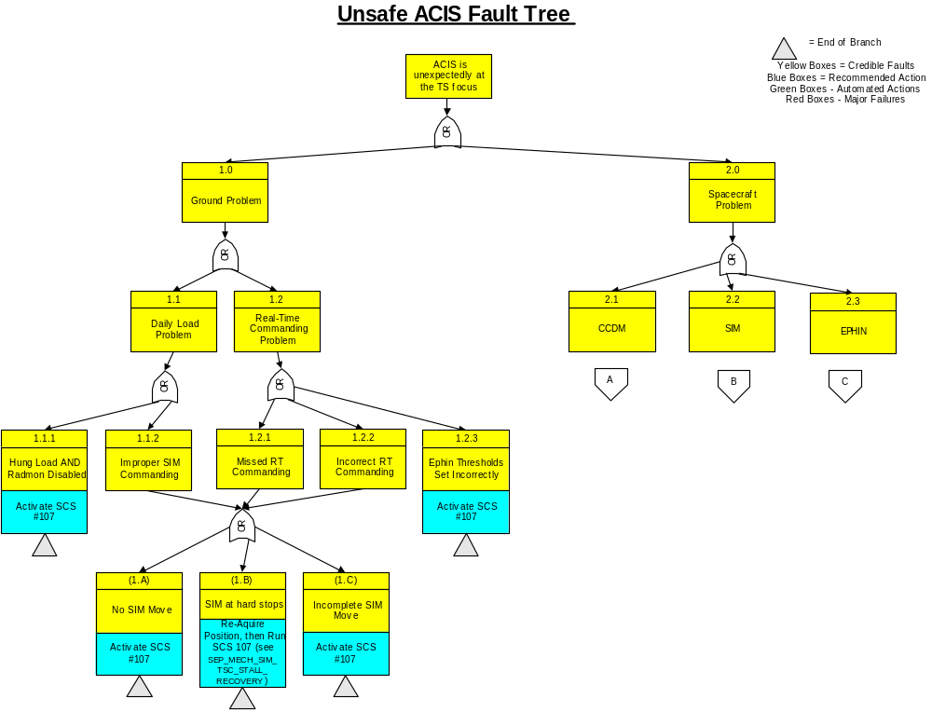Appendix 2 - Unsafe ACIS Fault Tree

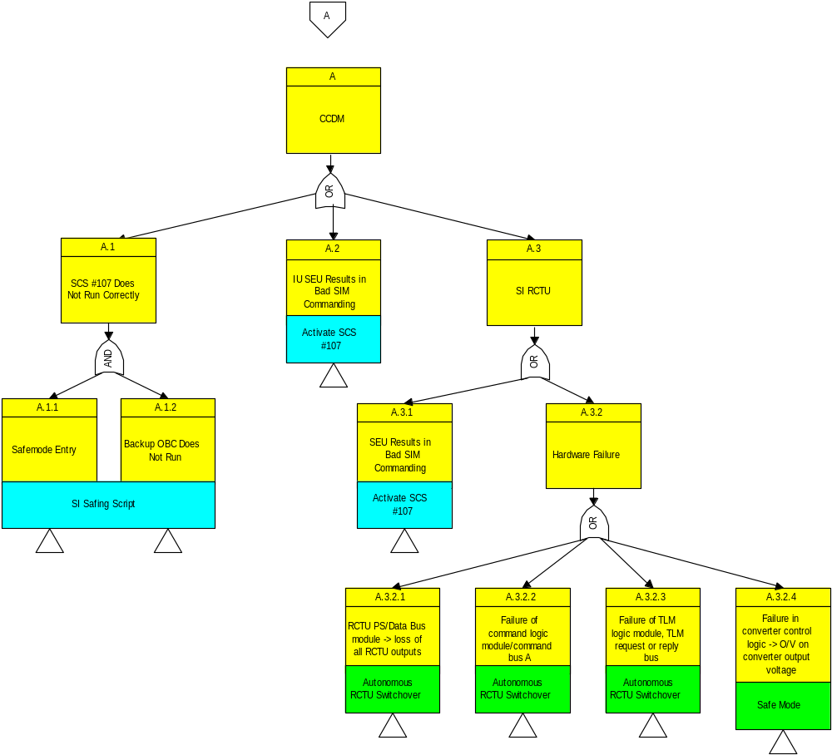

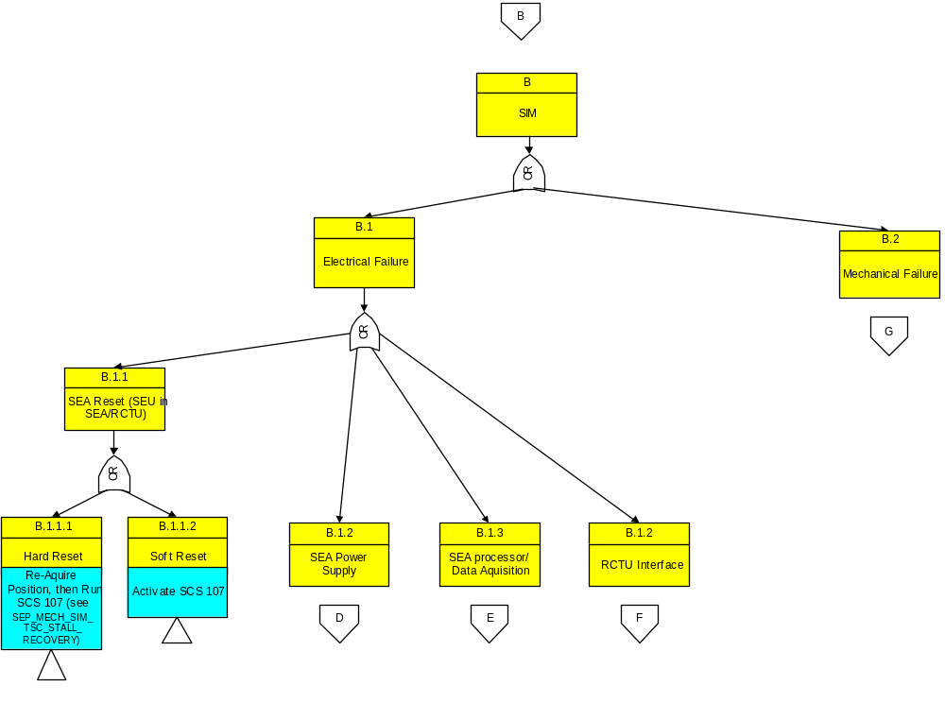

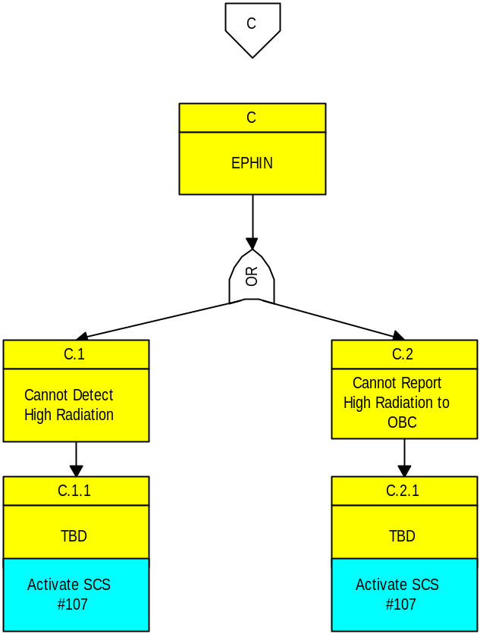

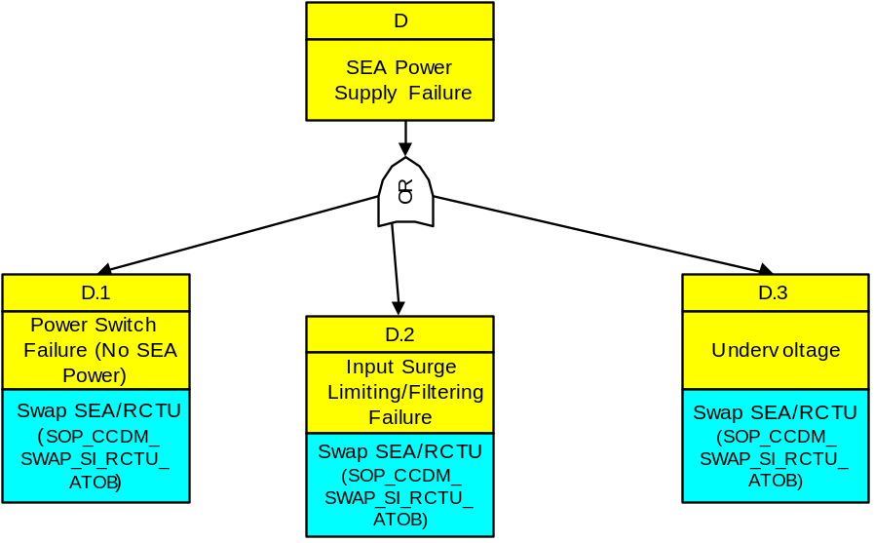

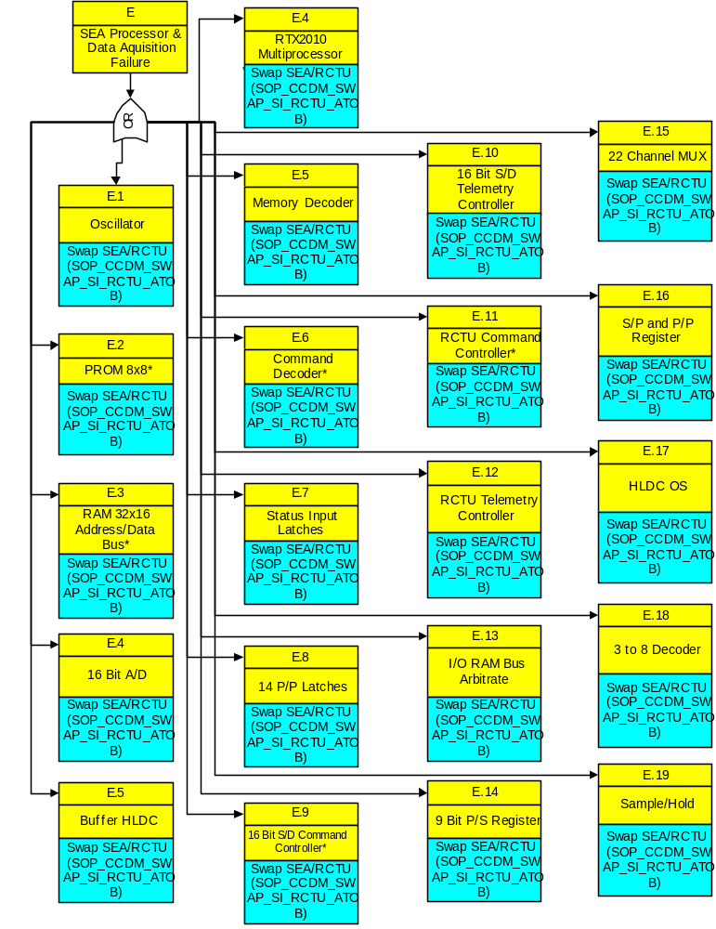

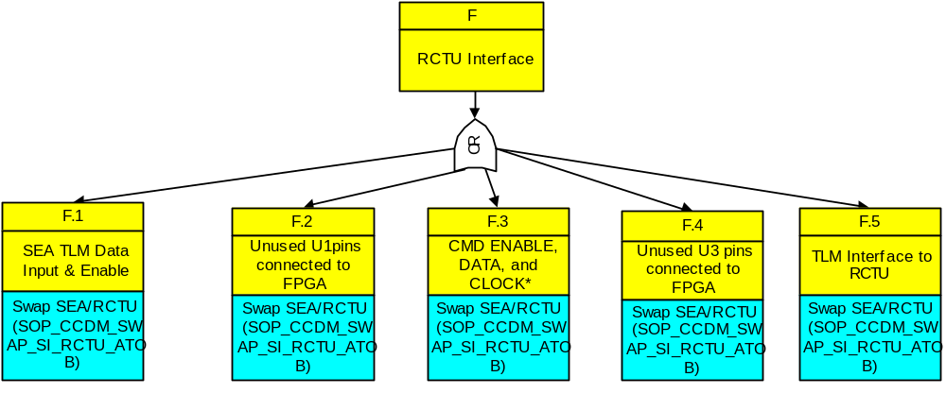

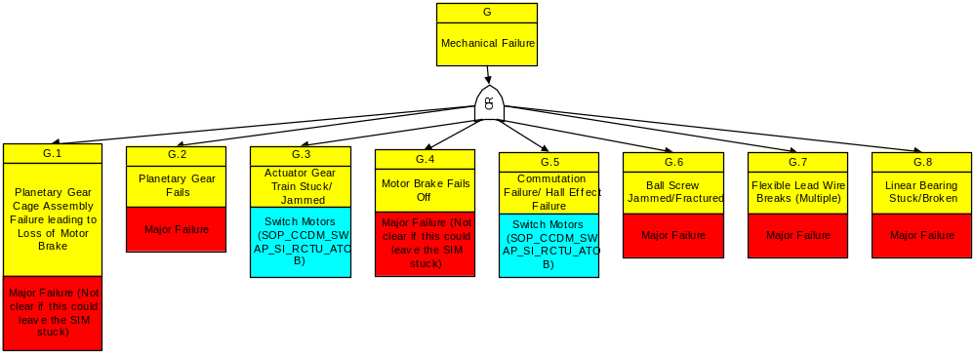

Appendix 3 - History

KEYWORDS: | ACIS, UNSAFE, SIM, PHASE2
HISTORY: | NAME | AUTHOR | REVISION | DATE
HISTORY: | SOP_SYSTEM_UNSAFE_ACIS_  PHASE2 | F. Richard Myers | 3.0 | 03/08/02
EXTERNAL  REFERENCES: | SOP_OPS_UNSAFE_ACIS_PHASE1

